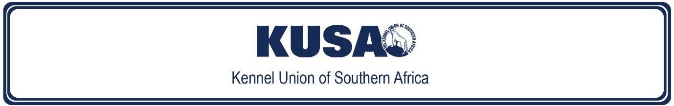

SCHEDULE 11 [C]
KENNEL UNION OF SOUTHERN AFRICA
REGULATIONS FOR TRICK DOG TESTS

EXTRACT

ELEMENTARY TRICK DOG
This is an optional class only if a dog has already achieved Canine Good Citizen Bronze. Dogs which have achieved Canine Good Citizen Bronze may proceed to Beginners. Dogs that have not yet achieved Canine Good Citizen Bronze must start in Elementary Trick Dog. This class is recommended for people who have never handled a dog in competition before. As these tricks form a solid foundation for many of the tricks to come, it is recommended that dogs are able to perform these tricks before proceeding to higher levels.

TIPS FOR SUCCESS

- Dogs must be at least 6-months old to participate.
- Dogs must show eight (8) tricks from at least four (4) different categories.
- You may have food on your body (which includes treat-bags and/or pockets). Handlers may reward their dog after each trick is performed. Luring with toys or food will be allowed in the execution of 4 of the 8 tricks and handlers must indicate whether or not they are using a lure. If the test is performed live, the evaluator must ensure that the handlers use food judiciously, showing due consideration for other handlers undertaking testing at the time.
- Show each trick twice consecutively unless specifically stated otherwise. I.e. show as described in the criteria and once again.
- Dogs must be off-lead unless leash-laws dictate otherwise, i.e. the park, training club etc.
- Pay close attention to the time a dog must hold a position, e.g. sit for 3 seconds.
- Pay close attention to the distance required.
- Tricks may be clustered where this makes sense, e.g. sit / stand / down (shown 2 x).
- Wherever possible, tell the Evaluator what trick you are doing. This can be done via subtext, signs or simply saying what the trick will be.
- Preferably film in landscape to avoid you and/or the dog leaving the frame.

Lists of tricks:

Category | Trick | Link to video example
Balance & Coordination | Balance beam (plank)  Plank flat on floor; width of plank slightly wider than dogs shoulder width; plank at least 2.5 m long
Foundation | Come  Return to handler when called; response immediate but speed not important; distance of 5 body lengths | https://youtu.be/b58XtG-eMGU  https://youtu.be/11TCYlyPDE0
 | Down  Dog to lie down from either a sit or stand; hold for 3 sec | https://youtu.be/SOZ6L42rh9I
 | Focus (hold eye contact)  Dog to look at handler; hold for 2 sec | https://youtu.be/F_zFyC85LG8
 | Muffin tin game  12 muffin tin size; 4 balls in tin; 1 treat | https://youtu.be/RKX5goV292Y  https://youtu.be/3EMKbEu6OPM
 | Pull on a rope/tug  Dog to pull for 3 sec | https://youtu.be/Hmaffeevrvc
 | Sit  Dog to sit from either a stand or down; hold for 3 sec | https://youtu.be/5i_ur6AHIac
 | Stand  Dog to stand from either a sit or down; hold for 3 sec | https://youtu.be/DXGpeWaW1_A
 | Walk on a loose leash  Dog to heel total of 20 handler paces; 1 change of direction and halt; dog can be in any position for start/stop | https://youtu.be/s4fEW4mKS3s
Hold & Fetch | Chase object  Object must constitute a toy, e.g. tug toy, squeaky toy etc. Item must be retrievable (but not necessarily retrieved) | https://youtu.be/Rf1zWCavUMY
Paw tricks | High five  Dog sits and touches the handler's hand in a "high Five" fashion (vertical hand). 1 paw only | https://youtu.be/kTGZxzLORU8
 | Shake hands  The dog puts a paw into the handler's presented hand - hand is presented horizontally. The handler does not have to "grab" the paw but may do so if they wish. If the handler chooses to grab the paw, the dog must not look uncomfortable and try to pull away. 1 paw only, the handler may use any hand | https://youtu.be/l25I1p-Am1Q  https://youtu.be/bP_cVFg9mIQ
Props | Tunnel  The dog moves through a "tunnel". Tunnel should be at least the dog's body length. Handler may be in any position | https://youtu.be/Zz8DQ9pF804
Scent games | Memory game (3 baskets)  The dog must be under control. The handler puts a treat into 1 of 3 containers. The dog is then cued to find the treat. Handler may be anywhere
Target tricks | Target (nose) – object / hand  The dog touches either the handler’s hand or an object in the handler’s hand with her nose | https://youtu.be/Z-0_yEO_BcI
 | Target (paw) – object / hand  The dog puts a paw onto a target. Handler may be in any position; target may be any size and in any position | https://youtu.be/zdcgtDuSroA

